- Overview

This function allows the administrator to modify store-initiated transfers. The data is stored within the tables transfer and tranfr_item.

- Login Process

The login process should be the same as for User Administration.

- The “SI Transfer Admin” Window

After the supervisor successfully logs in, the program should display the “SI Transfer Admin” Window. This contains a list of all the applicable Store Initiated (SI) transfers.

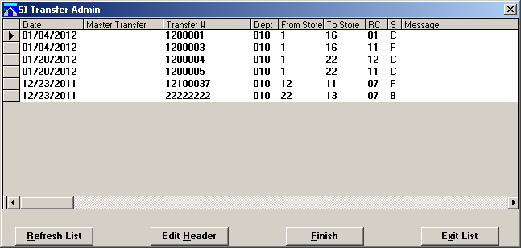

  - Database Details

select
tranfr_date,
tranfr_master,
tranfr_no,
tranfr_dept,
tranfr_from_store,
tranfr_to_store,
tranfr_reason_cd,
tranfr_status,
tranfr_message
from transfer
where tranfr_status in (“B”, “C”, “F”, “R”)
and tranfr_no <= 999999999
order by tranfr_no;

  - Buttons on “SI Transfer” Window

The Buttons “Refresh List”, “Edit Header”, and “Exit List” should always remain active. However, the “Finish” button will vary depending on the status of the currently highlighted transfer.

- If the status of the selected transfer is “C” (Closed), the button should be active and say “Finish”.
- If the status is “F” (Finished), the button should be active and say “UnFinish”.
- If the status is something other than “C” or “F”, the button should say “Finish” but be disabled

- The “Refresh List” Button

When the user presses the “Refresh List” button, the program should redraw the SI Transfer window with the current data.

- The “Finish/UnFinish” Button

If the user clicks on this button, and the highlighted row has the status “C”, the program should change the status to “F”. If “F”, it should change it to “C”. After the update, the program should refresh the window and highlight the row just updated.

  - Database Details

begin work;

update transfer set
tranfr_status = <new status>,
tranfr_status_date = TODAY
where tranfr_no = <current transfer #>;

update tranfr_item set
tranfr_status = <new status>,
tranfr_status_date = TODAY
where tranfr_no = <current transfer #>;

commit work;

- The “Edit Header” Button

Clicking the “Edit Header” button will cause the program to open the header (i.e. transfer) record for the currently highlighted row. The new window will allow the user to edit the header. Once the “edit header” window has been opened, focus should shift to this window, and the “SI Transfer” window should be disabled.

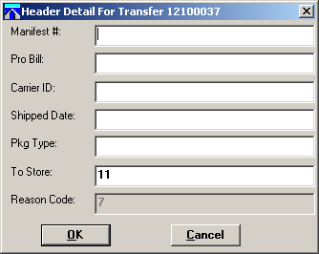

Note: If the transfer has the status ‘B’ or ‘R’, the program should not permit the header to be modified. Instead, it should display the message “This is an inbound transfer. Header cannot be edited.”

  - Database Details

select
tranfr_manifest_no,
tranfr_pro_bill,
tranfr_carrier_id,
tranfr_ship_date,
tranfr_no_pkg,
tranfr_to_store,
tranfr_reason_cd
from transfer
where tranfr_no = <selected transfer number>

  - Field Edits

“Manifest #” Field:

- If incoming manifest number = 0, field should display nothing
- Must be a number no longer than 9 digits

“Pro Bill” Field:

- If incoming Pro Bill number = 0, field should display nothing
- Must be a number no longer than 9 digits

“Shipped Date:” Field:

- The date must be keyed in the format “mmddyyyy”. If possible, need to validate that the number forms a valid date, i.e., not “06312012”.

“To Store:” Field:

- If the store number is something other than ‘22’, it cannot be changed to ‘22’.
- If the store number is ‘22’, it cannot be changed to another value
- If the store number is changed, the new value must be checked against the ‘store’ table. The record must exist, and the ‘homestore‘ field must not equal “X”. (“X” means that this is the number for the current store.) If the record does not exist, the program should display the error message “nnn not a valid store”. If the homestore field = “X”, the program should display the messge “Cannot transfer to same store”.

select
store_no,
homestore
from store
where store_no = <new store number>

“Reason Code” Field:

- Must be displayed but grayed out

  - Database Details

update transfer set
tranfr_manifest_no = <Manifest # from field>,
tranfr_pro_bill = <Pro-Bill from field>,
tranfr_carrier_id = <Carrier-ID from field>,
tranfr_ship_date = <Shipped-Date from field>,
tranfr_pkg_type = <Pkg-Type from field>,
tranfr_to_store = <To-Store from field>
where tranfr_no = <selected transfer number>

Prior to performing the update, the data should be prepped:

- If manifest # is blank, assign zero to field
- If pro-bill is blank, assign zero to field
- If carrier-ID is empty, assign space to field
- If ship-date is empty, assign NULL to field
- If pkg-type is empty, assign space to field

- Double-Clicking on a Transfer Header Record

Double-clicking a header row will cause the program to open a new window listing the detail records associated with the transfer record.

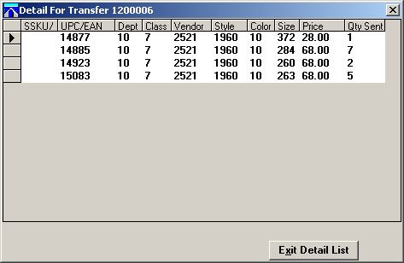

  - Database Details

select
(tranfr_sku_overflw * 100000000) + tranfr_sku ssku,
tranfr_dept,
tranfr_class,
tranfr_vendor,
tranfr_style,
tranfr_color,
tranfr_size
tranfr_retail,
tranfr_qty_snt
from tranfr_item
where tranfr_no = <selected transfer number>
order by sku;

  - Double-Clicking on a Transfer Detail Record

Double-clicking a detail row will cause the program to open a new window where the user is able to modify the quantity sent.

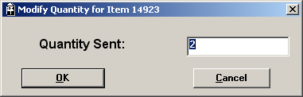

The new value for the field should be within the range 0 <= new-value <= 9999. After the database update, the program should close the “update” window and return to the listing of detail records. The row just updated should be highlighted.

    - Database Details

update tranfr_item set
tranfr_qty_snt = <new value>
where tranfr_no = <transfer header value>
and tranfr_sku_overflw = <upper half of SKU>
and tranfr_sku = <lower half of SKU>;

